Nepal College of Information Technology
Assessment
Fall 2010
Program: ELX/CE Time: 3 hrs
Semester: Fall (V) FM: 100
Subject: Integrated Digital Electronics PM: 50

The figures in the margin indicate full marks.
Attempt all the questions:

1 a) Explain why fan-out (N) is limited in a logic gate?Assuming β = 70, V_{BE (on)} = 0.65V, V_{BE (sat)} = 0.75V, V_{CE (sat)} = 0.2V, calculate fan-out for the BJT inverter G1 shown below when i) NM_{H} = 0. [3+4]
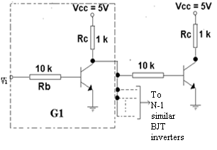
b) How does IIL offer a high packing density?Draw and explain a 2-bit IIL decoder. [4+4]

2. a) At T= 125°C, assuming the temperature sensitivity of the emitter junction as well as the diode is -2 mV/°C., answer the following questions, referring the following circuit. [10]
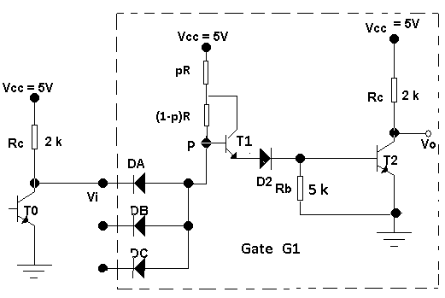
i) Calculate the input voltage V_{i} when the transistor T₂ is at the edge of cut-off.
ii) Calculate the change in current ∆I_{D2} flowing through the diode D2 when the transistor T2 switches from the edge of cut-off to the edge of saturation. Assume h_{FE} =50 and σ=0.85.
iii) Calculate the input voltage V_{i} when the output transistor T₂ is at the edge of saturation, and when the diode DA just cuts off.
iv) On the basis of above calculations, plot the input-output characteristics of the above shown DTL gate G1 at 125°C.

b) The OR output of the ECL gate is shown below to be fanned out to N similar gates. Find N at room temperature if the ∆1 noise margin is to be 0.3. Assume that the resistors of driving stage are 20% higher than typical and the resistors of driven stages are 20% lower than typical. The supply voltage is 10% higher and the transistor have current gains, h_{FE} = 40.The departures from the typical values are all in the direction to reduce the fan-out. The typical values are R_{C2} =300Ω, R₄ =1500Ω, R_{e} =1180Ω and V_{EE}=5.2V. [5]
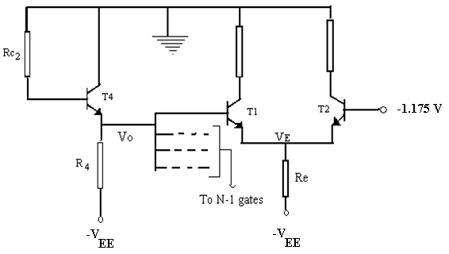

3. a) Draw the high speed TTL circuit and explain how the following factors account for the high speed in it. [8]
i) The input diodes
ii) The darlington circuit
iii) The active pull-down
b) “TTL is faster in speed than DTL but slower than ECL.” Explain with appropriate reasons and diagrams. [7]

4. a) For Kn=Kp,V_{T} (n)=V_{T} (p)=2V and Vss=10V,explain and plot the CMOS inverter transfer characteristics. [7]
b) Derive an expression for the input voltage in CMOS inverter when both the transistors are in saturation. [4]
c) The rise time in NMOS is extremely long in comparison to the fall time whereas in case of CMOS both are almost equal. Why? [4]

5. a) Draw and explain read, write and refresh operations in a four-transistor MOS dynamic memory cell. [8]
b) Give an introduction of VHDL and explain the basic structure of a VHDL file. [7]

6. a) Write the behavioral description of a negative edge-triggered 3- bit up/down counter that counts up when X=1 ,else counts down. [7]
b) Consider a simple digital circuit that warns car passengers when the door is open or the seatbelt is not used, whenever the car key is inserted in the ignition lock. Give the behavioural as well as the structural description of the circuit using VHDL. [8]

7. Write short notes on.(Any Two) [10]
a) Charge compensation
b) 2-input NMOS NOR gate
c) ECL gate interconnections
d) Comparison of HTL with DTL.

